**Upload Details**

**Send Feedback**

A very large institution has hired you to build an application for them. They have a very large database of students and now want to move it online.

You have to build them a web page that takes student data and then enter a new record into a list on that same page.

All the fields are necessary to be filled and the addition of a new record is directly visible on the screen. They also want the page to look simple yet attractive.

**When some data is added to the list it will look like this -**

[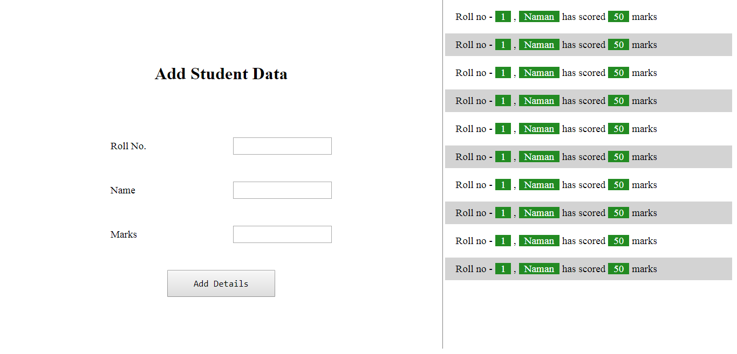](https://ninjasfiles.s3.amazonaws.com/0000000000002015.png)

**When the list does not fit on the screen, it becomes scrollable like this -**

[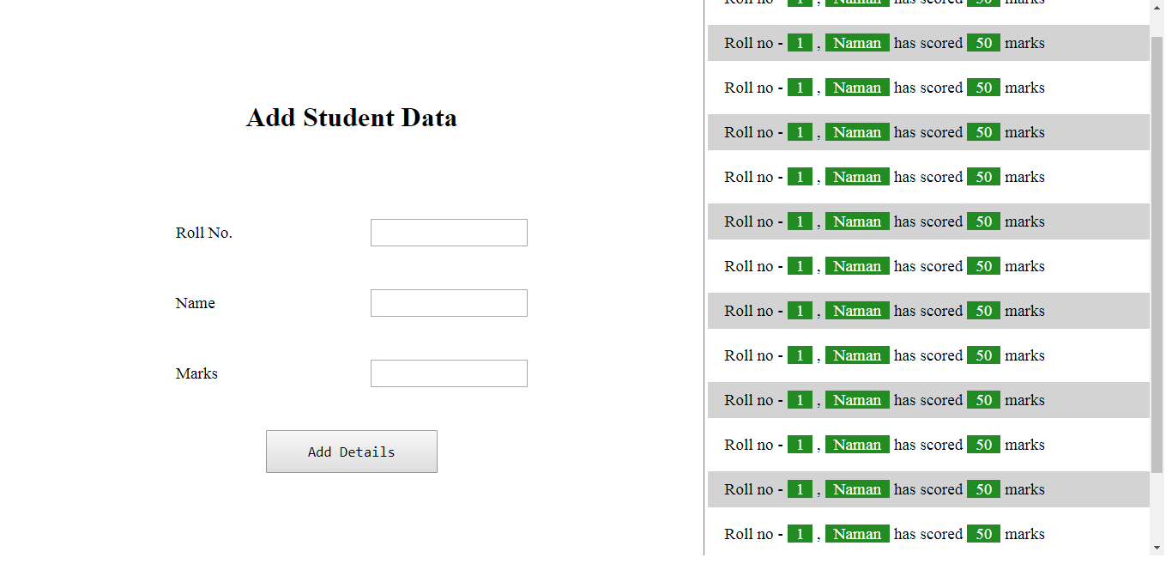](https://ninjasfiles.s3.amazonaws.com/0000000000002016.png)

**And you will get an error like this if any of the field is left empty -**

[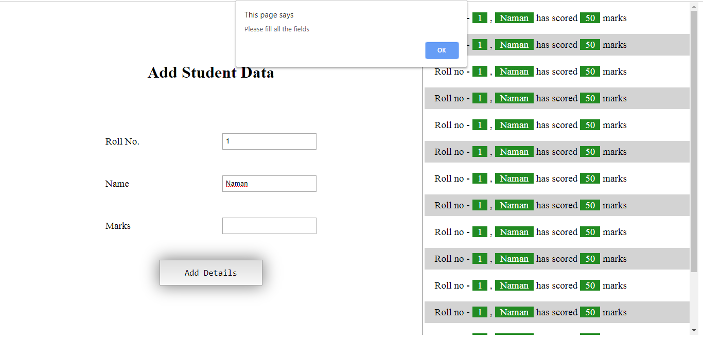](https://ninjasfiles.s3.amazonaws.com/0000000000002017.png)